Hauraki Series
Race 2 – Saturday 9th March 2019

Hosted by: Te Aputa Tira Hoe
Venue: Te Puru, Thames Coast
Distance: Novice/Junior 8km- Senior 16km
Type: W6, W2, W1
Divisions: Men/Women/Mixed/Novice/Junior/Secondary school
Cost:
$20 per senior paddler – if you enter online
$25 per senior paddler if you enter on the day (please see how to enter below for more details regarding this fee)
$15 per junior paddler. (One fee even if racing multiple times.)

Race 1: Novice/Junior W6, all W1/W2 Race 2: Women’s, Mixed W6
Race 3: Men’s W6

Event Schedule: Saturday 9th March 2019 8:00am Registration
  - am Race 1 briefing 10:00 am Race 1 start 11:00am Race 2 briefing 11:30am Race 2 start 11.50am Race 1 Spot Prizes 1:00pm Race 3 briefing 1:30pm Race 3 start 1.50pm Race 2 Spot Prizes 2.50pm Race 3 Spot Prizes

How to enter:
Your club Rep can enter all waka ama entries online.

Please note entries on the day will
- cost $25 per adult
- be limited
- require that paddlers produce their Waka Ama NZ ID as verification of their affiliation to Waka Ama NZ.

Payment:
Once entry is in please make Payment to: Te Aputa Tira Waka 38 9016 0618893 000. Please use your team name, race number and division as reference.

Hauraki Series events:
Event 1: Saturday 23rd Feb – Te Whanau Waka Ama o Whangamata - Whangamata Event 2: Saturday 9th March – Te Aputa Tira Hoe – Te Puru
Event 3: Saturday 16th March – Whitianga Communitiy Waka Ama - Whitianga
Saturday 23rd March – Hauraki Waka Ama - Waihi

Series Points System
1st Place – 4 points 2nd Place – 3 Points 3rd Place – 2 Points 4th + = 1 Point

Teams have to participate in a minimum of 2 events to be eligible for series points. Teams must race under the same team name for all events to accumulate points.

Series prizegiving will hosted by Hauraki Waka Ama at the conclusion of the 4th Event

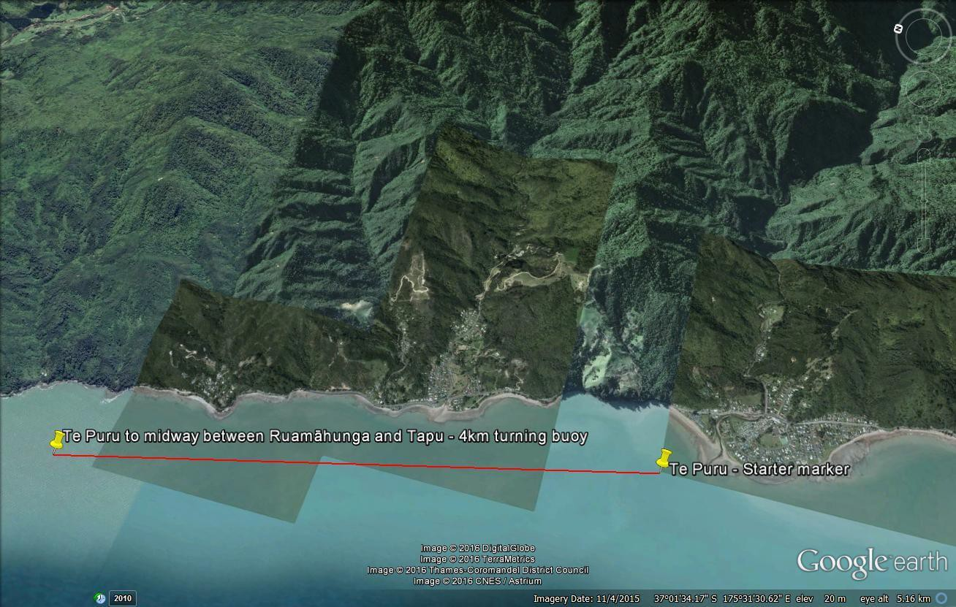
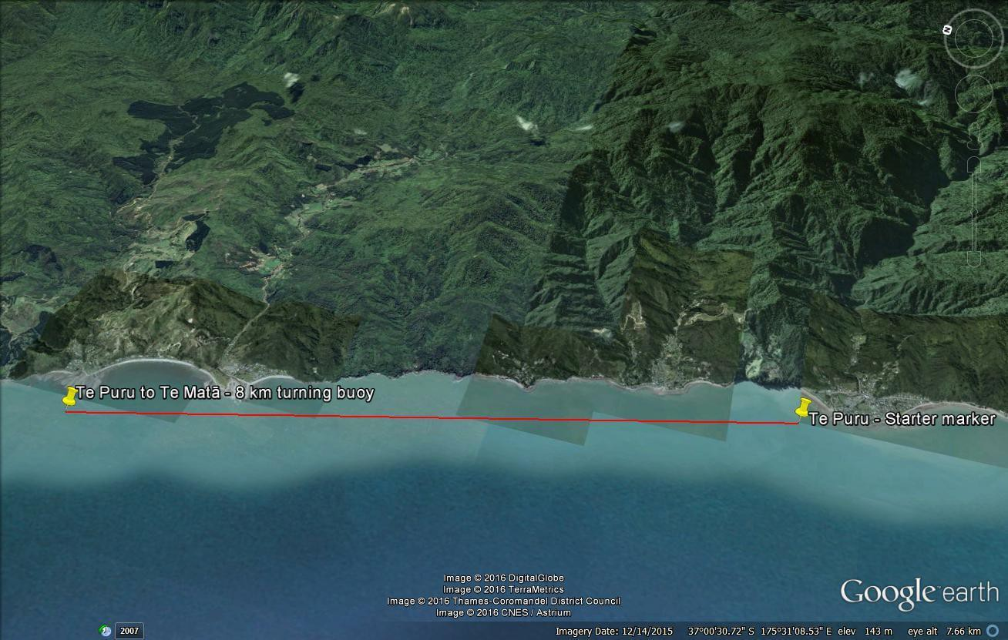
Race Course: 8km
Race Course: 8km
Race Course: 16km

TIDES
Low Tide : 5.51am High Tide: 12.01pm

Compulsory Equipment:
The following equipment must be carried by all waka and will be checked at gear check
    - 1 life jacket per paddler (must fit correctly)
    - 2 bailers W6
    - 2 Spare paddle W6/ 1 spare paddle W1,W2
    - 25m Tow rope W6
    - Spray skirt – may not be required depending on conditions
    - High Vis Gear (Shirt/Hat or Flag to assist with visibility)

Recommended
- Cell phone in waterproof bag
- VHF Radio

Back up Race course:
The course can be altered to suit conditions should weather be rough. There are 2 alternative courses for each race.

Cancellation:
- Novice/Junior Race will be cancelled if winds are above 25knots
- Mens and Womens W6 Race will be cancelled in gale force conditions or where wind speed reaches over 30 knots.

